ASSIGNMENT – 4

|  |  |
| --- | --- |
| Assignment Date | 23 October 2022 |
| Student Name | S.VARUNKUMAR |
| Student Roll Number | 820319106025 |
| Maximum Marks | 2 Marks |

# 

# OBJECTIVE:

To develop a code and make connections in wokwi for ultrasonic sensor, whenever distance is less than 100 cm send “Alert” to IBM cloud and display in device recent events.

# CODE:

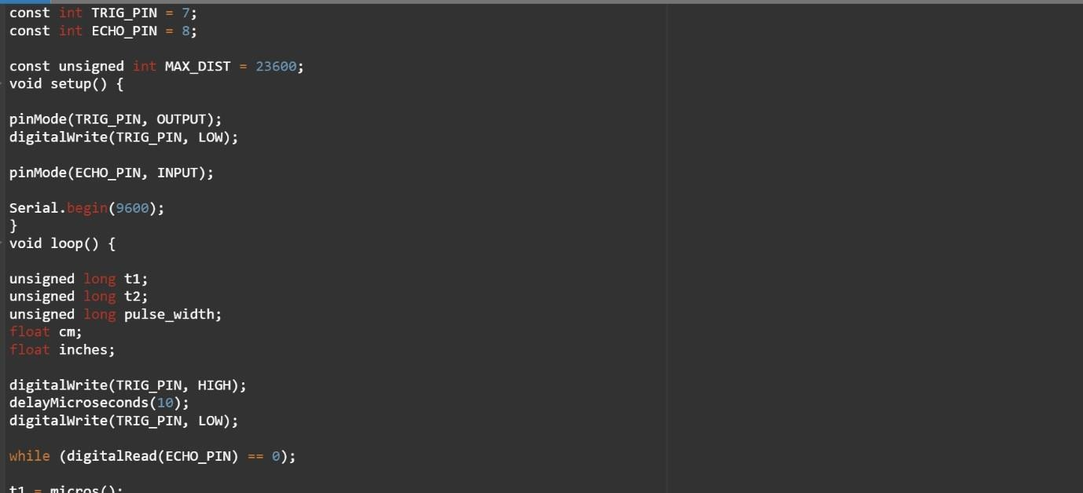

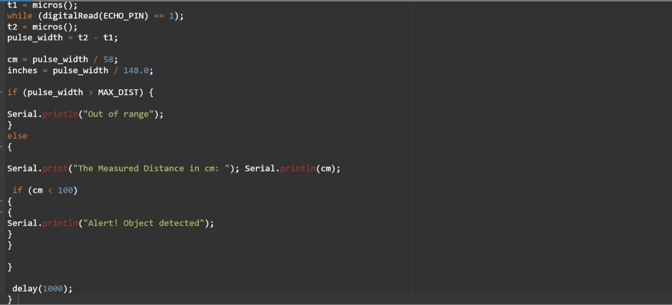

**SIMULATION**

